Solent University:

School of Media and Arts

2lavea02 – 2lavea02@solent.ac.uk

Communal Language Learning/Teaching website

CDA600 Project

**Date of submission: May 2019**

**Final Project Report AE2 (60%)**

[Aston Lavender]

**Academic Year 2018-2019**

**BSc (Hons) [Computing]**

# Acknowledgements –

As the dissertation comes to an end, I’d like to say my thanks to the people that helped me make it happen. Firstly, I would like to thank my supervisor: Mr Craig Gallen, he has provided me with expertise, guidance and given critical feedback which has led to the work that has been created up to this standard.

Secondly, I want to thank other tutors who have been there also as support and to give expertise in their major. Darren Cunningham and Nick Whitelegg, you have both provided me with knowledge and tool that were necessary to put me in the right direction and complete my dissertation.

I would also like to thank my university colleagues and friends because they have been with me from the start of the dissertation till the very end, giving me support when needed and general counsel who can help me find problems within my work when I could not. I want to say thank you to my best friends Nathan Baker, Andrew Walters, Sanah Rathore and Hamzah Javed.

Finally, I’d like to thank my family who always gave me their advice and counsel when things got tough. You have always been there for me when I needed it and I am forever grateful, while also distracting me when I needed a break.

# Acronyms –

SCT – Social Cognitive Theory

PHP – Personal Home Page (Hypertext Preprocessor)

JS – JavaScript

HTML – Hypertext Markup Language

# Chapter 1 Abstract –

After considerate amount of research has gone under way, it opens up options to how to implement a solution to the hypothesis. For example a web application of some sort will need to be made to allow communication with other users on the website.

As language learning is slowly gaining in popularity, websites and apps have begun to thrive within the market. The overall write up of this dissertation will consist of literature reviews to understand what motivates people to teach languages and to learn languages. Research has been able to show many theories behind language teacher theories, and how they are motivated to teach within a classroom or one-to-one. The aim of the research is to determine whether such a website can thrive with the large amount of language learning websites and resources, and if so, how?

The problem that would need to be addressed is how the website would be able to compete with other language learning and language teaching websites? Surveys gathered can give insight into what can attract users to the website, what they look for in an online teacher, what would motivate them to stay on said website, and if teacher/students expect something in return or not.

Contents

Acknowledgements – 1

Acronyms – 1

Chapter 1 Abstract – 1

Figures List - 3

Chapter 2 Introduction/Background hypothesis – 4

Hypothesis – 4

Chapter 3 Literature Review – 4

3.1 Motivation to learning – 4

3.2 Social Cognitive Theory – 6

3.3 Motivation to teaching – 6

3.4 Duolingo Language learning website – 8

3.5 Open culture – 8

3.6 Usability and pedagogical design: Are language learning websites special? - 9

3.7 HelloTalk – 9

Chapter 4 Project specification/requirements 10

4.1 Non-Functional Requirements – 10

4.2 Functional Requirements – 10

4.3 Project acceptable constraints – 10

Chapter 5 Design – 11

5.1 Pseudo Code - 11

Chapter 6 Methodology – 12

6.1 Testing/Surveys – 12

6.2 Survey influence – 12

6.3 Professional, legal and ethical issues – 13

6.4 Professional issues - 13

6.5 Legal issues - 13

6.6 Ethical issues - 13

Chapter 7 Project management – 14

Chapter 8 Results – 15

8.1 Survey results - 15

8.2 Motivation to learning – 18

Chapter 9 Implementation – 24

9.1 InfinityFree Hosting service – 24

9.2 WebSocket – 24

9.3 HTML/PHP/AJAX Short Polling – 25

9.4 Showing implementation - 26

29

9.5 Addressed Issues - 32

Chapter 10 Conclusions – 33

10.1 Ethics form alterations – 33

Chapter 11 Recommendations for further work and/or discussion – 34

References - 34

Lavender, A. (2019). *AstonLavender96/FMP*. [online] GitHub. Available at: https://github.com/AstonLavender96/FMP [Accessed 2 May 2019]. 35

Bibliography – 36

Appendices – 37

Appendix 1 – Ethics Release form 37

# Figures List -

Figure 1 - How many languages each participant knows at a given level 15

Figure 2 - Response to the question: how has learning more than one question benefitted you? 16

Figure 3 - rest of responses to the question: how has learning more than one question benefitted you? 17

Figure 4 - Types of learners the participants are 18

Figure 5 - Results of participants to see if they considered teaching 19

Figure 6 - Results to the question that describes their experiences when teaching a language. 19

Figure 7 - Do you think one-to-one communication benefits you and/or others when learning/teaching languages? 20

Figure 8 - Results to determine whether participants would integrate culture into teaching or not 21

Figure 9 - What participants expect from online teachers 22

Figure 10 - Rest of answers from participants and what they expect from online teachers 22

Figure 11 - Results to the question "The whole website is provided for free, what could be offered to teachers/students that will make them want to come back?" 23

Figure 12 - Rest of results of the question "The whole website is provided for free, what could be offered to teachers/students that will make them want to come back?" 23

Figure 13 - Results of question "To summarise, this website is being created for the users that wish to learn or teach in their own time, would you use a website like this?" 24

Figure 14 - Bits per second comparison between WebSockets and Polling sending small messages (Lubbers and Greco, n.d. 2019) 25

Figure 15 - First page when searching fora teacher/learner 26

Figure 16 - findpeople javasript page that searchs for users and sends information back to the searchpeople.php page 27

Figure 17 - php that searches the users username and checks they are online. 28

Figure 18 - php page that gets all users from selected options 28

Figure 19 - HTML layout of found users 29

Figure 20 - Form used to send messages. 29

Figure 21 - Script that runs when the user clicks send 30

Figure 22 - PHP page that reads the message sent and posts to database with given variables 30

Figure 23 - JavaScript loop looking for new data from recmessage.php 30

Figure 24 - PHP SELECT query to pull the last message sent in the chat 31

Figure 25 - Global variables used in Chat.js 31

Figure 26 - fixed issue of chatroom not sending back any messages. 32

Figure 27 - line of code to produce message received into the chat room 32

# Chapter 2 Introduction/Background hypothesis –

This project begun at the beginning of academic year and the decision has been made to create a functional website for language learners and aspiring language teachers. Multiple steps are required to create said website, although it may run into problems that may not be fixable, possibly due to the period that has been set or the task is too difficult. If anything were to be changed, documentation of said problems and actions taken to fix the problems will be within this report.

Looking into the scope of things, people sometimes have the desire to learn a language in their own time and therefore going online to find resources/websites to improve their learning. If the user does not wish to spend money, there is a limited amount of resources that they can gain access too, but if they were to pay a monthly subscription or a one-off

payment, they have unlimited access to all learning resources of their target language. It can be a disadvantage to some due to the fact that they do not wish to spend money on a hobby as a vast majority lock out large amount of information so they user is inclined to spend money.

The purpose behind this paper is to determine whether the hypothesis is possible and/or reachable in the time given. If the initial project idea cannot be met fully, precautions will be taken to make sure that it provides its main functions for the users. As well as this, it is to keep track of the entire process that ultimately leads to the final product.

The hypothesis has been decided, there will be a lot of research that needs to be covered regarding language learning, its theories and reasons behind learning languages. As the website is to help facilitate language learners and teachers, research for both language learning websites and language tutor websites will need extensive research into why they are succeeding and how this website could also become well known and popular.

## Hypothesis –

**Given the large amount of commercial websites that already facilitate language learning, what requirements would enable a crowdsourced community-learning environment to compete and thrive?**

# Chapter 3 Literature Review –

## 3.1 Motivation to learning –

While some people learn because they have to(school), to be able to improve they have to be motivated or they will not retain any knowledge from learning materials.

From many researchers, they have theorized that motivation is playing a vital role when it comes to learning a language.

Looking into the scope of things and the pedagogical process of students who are learning their second or third language, there are topics that need to be addressed in terms of motivation. There has been research that has been influenced by a psychologist by the name of R. C. Gardner, and his associates. From this, he created a model that classed motivation on two levels: Oriented motivation and core motivation. Gardner saw core language motivation as a construct of three features: affect, want and effort, this is looking the learners attitude, their desire to learn and the amount of motivation.

To be able to know what motivates people to learn languages, Gardner suggests that you must know the learners ultimate goal for learning in the first place, as if they were to have no goal, they would not be as motivated to learn. Gardner called this learners orientation. - Liuolienė, A. and Metiūnienė, R. (2006)

When learning languages, there are different purposes behind why people learn. One for example would be an integrative reason, where the users wish to learn more about the target languages communal culture. Another example would be where the learners would like to language as a challenge, and for an aim like an exam, or to be able to advance in their workplace. There is an obvious difference as both learners have different motives to learning languages, some do it because they may have to learn a language to progress in their career, where others may do it as they find the target language interesting and wish to learn more about its culture from their perspective. - Liuolienė, A. and Metiūnienė, R. (2006)

As such people are learning their second language, these two reasons will not always be why they are learning the language, there are many other reasons as to why people wish to learn another language. When it comes to making a website that supports language learners, it is best to understand why they learn, as well how. One of the project aims is to bring in people who know 2+ languages, English is going to be recommended due to the fact it is a universal language and many users will already understand the language to a certain extent.

Within this article, there is more than just two orientations to motivational learning, there are conditions that need to be considered to gain more understanding in learners reasons. These conditions are: Interest, Relevance, Expectancy and Satisfaction. Learners will typically need some interest in the target language or they will not feel motivated enough to put in the effort of learning the language. Some students may relate their motivation to the relevance in their lives, they may move away to a country where they have to learn the language. Others may be expected to learn a language, students at school are required to learn a language for their studies, they might also set their own expectations for what they want to learn. Satisfaction is another condition taken into consideration, learners like it when they set a goal and accomplish it, feeling satisfied with what they have learnt and what they can now use in the future. - Liuolienė, A. and Metiūnienė, R. (2006) Pg. 95

No matter how you look at motivation, there will always be a significant difference depending if the students need to learn a language (School, Work), and students that want to learn a language (Self interest, satisfaction).

## 3.2 Social Cognitive Theory –

This theory in particular takes into consideration different factors on how the brain works and learns. Social cognitive theory is said to evaluate experiences of the learner by considering the learners past with the same factors, which is learning. In basic terms it evaluates the present experiences against the past and see if there are any differences.

SCT is not simple to explain without looking into its three main factors that determine the learners approach to learning. It is because of these three factors that learning is able to occur as one factors can join into another factor. Behavioural factors associate with both personal and environmental factors, and vice versa. - Mae Sincero, S. (n.d.).

Not only are there three factors with Social Cognitive Theory, there are also concepts that are looked at for learners, not only adults but also children. These concepts are ways that people learn best. Observational learning is a simple concept where the learner will simply observe and they may find it the best way of gathering knowledge. Reproduction, or repetition, is another concept, and the aim is to put the user in an environment with access to specific materials that should motivate and help them to hold new knowledge and behaviour.

Similar to the reproduction concept, self-efficacy is a concept to help improve the learner’s new knowledge by practicing it. Supported by the person’s own confidence to be able to complete a given task.

For someone to be able to learn easily their environment and surroundings are important, and its best to keep them from stressful environments away from anything negative. Doing so can lead to improved, effective learning.

Cognitive behavioural theory looks at the aspect of cognition, then be able to determine a certain individual’s behavioural pattern. Such a theory defines the individual’s self-concept that is created which can then affect the behaviour that they will display in terms of learning. Cognitive behavioural theory also explains that human learning and behaviour uses something called the cognitive triad, which contains negative thoughts about themselves, the environment, and the future. Having such negative thoughts governs the users outcomes and motivational levels when it comes to learning.- (Mae Sincero, S. (n.d.).)

## 3.3 Motivation to teaching –

While students need motivation to learn, teacher will need motivation to teach also, motivation for teachers can affect them in many different ways; such ways that is can affect a student’s learning capabilities.

By looking at already established cognitive theories of motivation that is aimed at student’s motivation, you can modify its understanding to suit teacher’s motivation.

As for teachers, self-efficacy is also related to their beliefs to be able to perform a task for their students at a certain level that they are satisfied with. It is based on the teacher’s decision that determines how they are capable of interacting with students and how they can help them improve. Furthermore, from self-efficacy relates to the teachers confidence, commitment, satisfaction, effort and persistence. *– (Klassen, R. 2011)*

Finding motivation to teach is similar to motivation to learn, but, there are different theories that imply that they are different. This article mentions theories such as self-determination theory, achievement goal theory and Expectancy-value theory.

From the naming of self-determination theory, the article suggests that one must have the psychological needs to be able to assert themselves. In this case, the workplace and develop workload that is appropriate to their target audience. For a teacher to be able to bring their class up to a certain level of understanding, they would first have to be determined to want to see the class they are teaching progress and further their knowledge on specific topics. Looking more into self-determination theory, the teacher needs some form of incentive or drive to teach in the first place, self-determination theory is where such drive comes from. Aspects of such a theory may come from feeling some sort of accomplishment while also seeing value in producing and implementing produced tasks. *– (Deci & Ryan, 2000,2012)* Motivation to teach commonly originates externally, implying that a teacher’s drive comes from an activity that has been successfully implemented, but also suggests that motivation can be intrinsic, this is a term commonly known as ‘integrated-regulation’.

To further the study of such theory, it can also be the pro-social value of teaching that motivates people to become teachers, such factors would be: love, passion, dedication to learners, as well as personal or moral commitments that they have made to society. Because of such feelings towards teaching, some individuals prefer such workload and commitment to a cause, as they are then able to evaluate their own expectations towards teaching levels to be able to realize their teaching abilities. *– (Richardson & Watt, 2014)*

Although these theories are generalized in terms of motivation, some concepts are used to determine the teacher’s motivation within the classroom and not just outside.

As spoken of before, SCT plays the same part in motivation, as well as looking at the teacher’s ability to be able to teach also. Their motivation in the classroom can come from the fact that they have somewhat full control of the whole session (what is taught, how it is taught, when to help the class, when to let them figure things out for themselves. Etc.). *– (Zee & Koomen, 2016).* From the teacher’s perspective, if they are fully aware on how they can help students in any problems, their motivation tends to improve greatly due to the individuals job satisfaction through their perseverance.

Achievement goal theory looks into what teachers are typically looking to achieve when teaching.*- Retelsdorf. J., Streblow, L and Schiefele, U(2010)* From the name, it would be easy to assume that the achievement goals are for students, but from the perspective of the teacher, it is to test and improve their abilities to teach. Following this theory, it suggests that it makes teachers want to not fail their students due to their poor teaching abilities, which is why teachers better themselves and find new ways to improve their lessons.

Following achievement goal theory, Expectancy-value theory expands on it as it is based off the teacher and their thought process and believing that they are aware they can expect successful results. It also comes from their ability to complete such tasks and how they are able to involve the students. *– Wigfield, A and Eccles, J. S. (2000)*

Some theories that reinforce teacher’s motivation also relate to students motivation to some extent, because of this it is safe to assume what can keep teachers motivated. Self-determination theory is a good example as to what could motivate teachers on this website as they would be motivated to use this website to try to bring a student’s skill up to a certain standard.

## 3.4 Duolingo Language learning website –

Looking into multiple language learning websites, Duolingo seems to be the most popular as well as the most affective for an interactive website and app. This website offers its users 30+ language courses that they can pick and start learning it. It is not English exclusive, meaning it can help people who wish to learn English from scratch; Duolingo starts each course typically with the alphabet that they need to learn before anything else. As well as that, it allows discussions with others that are also learning the same language ask questions, allowing others to respond and help them. In comparison to the project idea, it does not offer lessons as that would require extensive knowledge on different languages, which cannot be accomplished due to the period given. *– Duolingo(2018)*

As well as giving users tasks, a forum page is made that anyone is allowed to post on, this can be used to ask questions about a specific language, meet ups in certain places (possible cause for concern), and just generally questions and opinions on the website. Another section consists of events where people can set up events for people to join and meet said people in public to take part in lessons. Podcast page is something added for its users, specifically for Spanish language learners to use and learn from when they wish to try something new. A dictionary function is offered so the users can search for sentences or words, although the function itself is not 100% accurate, as it can sometimes not understand the sentences given.

Duolingo as a whole is a very popular and promising website, there is something that can be quite worrying, and it’s the openness of allowing to invite other people to meet via forums and events. On the other hand, most people that organise these events are from official groups so it is reassuring to know that, it is also possible that the events cannot be published unless the organiser of the events have been verified by Duolingo itself.

The project idea under the category of language learning will provide functions that will offer users to interact with other users; such a function will allow someone who wishes to teach other users or learn from someone who is willing to teach them.

## 3.5 Open culture –

This website provides its users materials that are not just used for language learning, but for any educational media that someone may want. People are able to provide others with materials that can help them learn languages for example. Instead of personally teaching learners, it gives them the option to be able to read educational materials and teach themselves. *- Jones, J. (2019).*

As this is beneficial to learners, it can also be misleading and can take a long time to navigate through such a website that may end up leading to a website that requires the user to pay. Open Culture is more of a hub that users given links to other websites that then provides them with resources. On the other hand, OpenCulture is not specifically aimed and language learning, it is generalised so it does not focus on its functionality, but its availability.

## 3.6 Usability and pedagogical design: Are language learning websites special? -

This paper examines usability and pedagogical design to see if language learning websites are considered special, and why.

When it comes to e-learning, there are specific requirements that would need to be followed within web based learning and e-learning. According to a researcher in educational applications of computing, *Laurillard(2002*) addresses issues of usability from a pedagogical point of view, while focusing on three aspects; UI, design of learning activities and checking whether learning objectives have been met. She explains that the aim is to design and interface that does not intrude on the main tasks at hand.

Taking into consideration of the web design, *Hale and French(1999)* described it as learning principles, for example: reducing conflict and frustration, repetition of concepts using variations in technique, positive reinforcement, student participation, organization of knowledge, learning with understanding, cognitive feedback, individual differences and motivation.

TELL (Technology enchanced language learning) This is something that integrates different approaches to the use of computers for language learning and teaching, one of which is Computer aided language learning (CALL). Drill type programs were intended to improve accuracy in learning a single language. TELL practitioners have been using the web for a means of developing materials for CALL, as well as supporting learners access to specific language materials and resources. This can give support to the learners in regards of engaging in the language and culture of their target language. - *Kukulska-Hulme, A. and Shield, L. (2004).*

Under pedagogical usability, it is already known that the purpose e-learning websites need to be clear is so that it can ensure that learners needs and expectations are met.

For language learning website, there are multiple choices that can or need to be made, and that is deciding whether they should use the target language or the first language. Websites often take a multimodal approach, from a pedagogical perspective, it needs to know how should such information be displayed and how it should be interacted by the users.

## 3.7 HelloTalk –

This app allows users to be able to search for users whose native tongue is a language that you wish to learn. It is known that there are many apps that provide language learning services, so trying to differentiate from all of them can be proven to be quite a challenge. If a new website/app were to come into the language learning market, it needs to have something unique that will want people to use it, and not use the others. The project idea is to not only encourage others to help one another teach and learning languages, it is also made to invite communities that can give insight to learners about a given languages culture.

As Hellotalk is a free app service that allows you to pick a language you wish to learn and connect you with native speakers of that language, it does not always guarantee that the users speak English fluently and that they are also trying to learn English, or another language for that matter. If they wish to connect with people of a different language, they would have to upgrade their account to a premium which costs a slight fee. *–HelloTalk. (2019)*

It gives users a built in translator that can translate their sentences to the language they are trying to learn to be able to send to the person they are learning from. From that perspective, it somewhat defeats the purpose of it being a language learning app as it gives the option to translate words and sentences for example.

From gathered information, such an app has its advantages and reasons as to why people are joining the app (Chat, interactivity). Although it also has its disadvantages as it. limits how you interact with the app (Can only pick one language as a free user, limited translations).

# Chapter 4 Project specification/requirements

This section will consist of information on how the project should be working, looking and functioning.

## 4.1 Non-Functional Requirements –

Frameworks will be used to help layout the website with ease. Bootstrap will be used.

PHP will be the language used to create the main functions of the website, as well as JavaScript and AJAX that will allow one-to-one chat functionality.

SQL is capable of storing information within a database, users accounts will be stored as well as their emails for multiple reasons (Forgotten password, Verification). Chat messages to be logged and saved within the database to allow saved chat messages.

HTML/CSS typically used to design the front end of the website.

Will be made on the computer, but may be accessed on mobile phones.

## 4.2 Functional Requirements –

Data that has been gathered will be stored within the websites database and the user’s information will not be sent to any third party websites.

A feature that will allow users to search for other users who are either teaching or learning a language.

A sign up/logging function will be created where the users can create their own usernames and passwords.

## 4.3 Project acceptable constraints –

Other functions are yet to be added, but due to the lack of time left to complete such tasks and the time it would take to learn such new functions.

A webpage exclusive to the users that lets them see the chats created with other people, for example: A chat between them and a teacher/learner that they have started. Another page would need to be created, allow the user to only see conversations they have made, or other users who have messaged them directly. To implement such a webpage, it would need the ID of both the sender and receiver of the message and send back a chat box, while displaying a message link to send the user to the chat room so they can communicate.

Another suitable function would be a notification system that informs users that they have received messages from other users, and then prompting them to click on the message and starting a chatroom with them and commencing conversation. The way this can be created is to create a new table for user notifications that is inserted into the database, from the same code it will contain the ID of the user giving and receiving the notification.

# Chapter 5 Design –

## 5.1 Pseudo Code -

As for the design of the website, it is how the website will function, navigate, and overall how it is going to work and interact with its users.

The main function is to set up a chat-room with a person that the user chooses to message. To make this it must:

IF the user has logged in with correct credentials

Allow them access to the page that searches for teachers/learners.

ELSE display and error message informing them to sign up/sign in.

IF credentials are correct

Display page with a FORM that allows user to search for learners/teachers.

SELECT all users who fit specified criteria (e.g. Teaching/French)

Click Send message

WHEN button is clicked to message user

Send user to chatroom page with connection to chosen user.

To send message:

Request ID of both sender and receiver within Javascript supported by AJAX

WHEN text is entered,

INSERT a message to the database (Another php page) with both ID’s as well as the message.

To receive message:

Create an AJAX HTTP request with JavaScript file that will parse the messages into JSON before displaying it for users.

GET the message from another PHP page

FETCH results

Display within chatroom.

To display name above the message sent:  
 Javascript function with AJAX

CREATE connection with a php page

GET the ID of receiver

ECHO user specific ROW before sent/received message.

# Chapter 6 Methodology –

Throughout the entire unit, it is expected that there be extensive research on the chosen topic, in this case, primarily research that is based around language learning, pedagogical research, language theories, and teaching English language learners. This research in particular has been chosen due to the fact that the website will be based off its users helping each other teach and/or learn, before this can be simply implemented, in-depth understanding of such topics is a necessity. From that knowledge, it can be used to be integrated into the whole websites design layout and functions which will please its users to the extent they will wish to keep using it.

There are however, boundaries as to how much research can be collected and used, when it comes to learning in general, there are so many sources that can be accessed, used and implemented. Albeit there is so much information in language learning, not all of it can be used as this website will be learning/teaching through technology (the internet). This does not necessarily mean that any other sources cannot be used and manipulated to accompany the implementation of the websites needs. To extend from this, information regarding the actual creation of this website will be required, although most knowledge has been learnt in the past 3 years at university, there are different methods that are required to be studied and learnt and then integrated into the website.

## 6.1 Testing/Surveys –

Further research will consist of collecting results from a survey that is aimed at people who know two or more languages. From the gathered information, it is possible to find answers that can help the process of creating the website and implementing what would benefit said participants.

The developer will conduct testing, as a survey will be able to give sufficient answers to the design and implementation of the website, just making sure the main functions work is the priority to this website, supported by the research and meaning.

Such a survey can help find reasoning behind the creation of this project, without some sort of feedback, there would be no reason for it. As well as this, the project has potential to fill a gap in the market where people are able to show the skills they have and develop them.

## 6.2 Survey influence –

The creation of the survey is to initially gain insight on people’s opinions on language learning/teaching. The best way to get such information is from people who have already learnt multiple languages because they will have more opinions and base knowledge. Before serious implementation of functions, it is best to get other people’s opinions on what they are looking for in a new website that encourages language learning/teaching.

From personal experience, language learning apps and websites do offer a wide range of support, from already created lessons/tasks that the student can complete, to apps that allow you to connect with people who speak a specific language that you wish to learn.

Some websites allow teachers to offer their services for a set fee per lesson, which could diminish a student’s motivation depending on the teacher’s abilities. There would be no reason to spend money to learn a language on one website, where another offers it for free, while both are benefitting from it in different ways. Questions will help determine what online students and teachers want or need from this website in terms of motivation and support.

## 6.3 Professional, legal and ethical issues –

There will be different issued when it comes to creating a communal website that anyone is able to use and message someone. Taking into consideration the legal issues first as they will be the biggest obstacle that needs to be dealt with before any other steps can be taken. Ethical issues would be taking into consideration the users thought and worries when they are using the website and giving their personal information.

## 6.4 Professional issues -

Professional issues need to be considered as they affect ethical and legal issues also.

As far as professionalism goes, it is all based on one’s opinion, and decisions made are made out of their best interest while considering user’s decisions to do certain things, such as they may wish to keep their personal data confidential. It is best to respect their choice, but if the author wishes to use people’s information, they must ask for their consent before doing so.

There are guidelines called Web Accessibility Initiative, and they can be followed by web designers, and these guidelines guarantee that the website can be accessible to users that are disabled to a degree, this could be audio or visual support for example. If such a website did not suit the needs of people with visual problems for example, it can be seen as insensitive to its users. *– [WAI (2014)].*

## 6.5 Legal issues -

As people use websites, some do not require some kind of sign up system, and therefore not taking any personal details. But if a website does require personal information such as websites, it can be possible that said emails can be sent to third party websites.

As GDPR (General Data Protection Regulation) is in place, guidelines are set so they need to be followed to develop websites in an ethical way, yet legal way. Data breaches are a prime example of legal issues that occur, if a website were to breach contract with its users by misusing their data for malicious intent for example, the website can receive fines for its misuse of the user’s data. *– [Falbe, T. (2018]).*

Copyright issues are common and also very serious in some cases, such as if someone were to take images, text/information and even developing scripts from other websites. Under the copyright act, there are rules on even images taken from third party websites and it usually always best to create your own images. If you did want to take images from other websites, some give exceptions to it as long as they are referenced correctly and the credit goes to the author. *– [Bolin, B. and A. Tysver, D. (2018]).*

## 6.6 Ethical issues -

Ethical issues need to be met as soon as possible and understood, as the website will need users to be able to thrive as a whole, and if they do not like the website, appropriate steps can be taken to ensure it keeps the target audience happy.

It is best to consider human rights when tackling ethical issues with web development, as everyone should be able to access websites freely with no discrimination against anyone or treated unfairly. Data can be a big problem in terms of ethical issues for the reason that they do not always want to give up their own personal data getting used or leaked to a third party website for example. As long as the website asks to use their data and that they also explain the reason they are taking said data and the users agree, there should be no problems. Users will always have the right to decide to take their information back from the website; this can be deleting the users account, as well as their information. *– [Falbe, T. (2018)].*

The users experience is top priority, as they are the ones that will be using the website, interacting and possibly giving personal information. It will need to look accommodating to all users, and the functions will work and run smoothly on the client side, spending as little time as they can when navigating around the website. Giving quick access to its main function is necessary if websites wish to thrive, depending on their aims of the website. With consent from its users, they will only share their personal information

# Chapter 7 Project management –

As the website is being developed, research is conducted to enforce reasoning behind certain methods used to create functions that users will interact with. Tasks are supposed to be met at a given time, management of time is essential.

|  |  |  |
| --- | --- | --- |
| Milestones | Start date | End date |
| Initial project start (finalising project idea). | Week of 24/09/2018 | Week of 8/10/2018 |
| Supervisor selection . | Week of 22/10/2018 | Week of 22/10/2018 |
| Ethical form completion, project agreement with supervisor. | Week of 29/10/2019 | Week of 9/11/2018 |
| Specific research taken place based off project idea, requirements necessary. Feasability report hand-in (15/02/2019) | Week of 12/11/2018 | 15/02/2019 (Hand-in) |
| Design website layout with Bootstrap. | Week of 18/02/2019 | Week of 25/02/2019 |
| Conduct survey.  Begin development of websites functions | Week of 25/02/2019 | Week of 4/03/2019 |
| Research Language acquisition theory, why/how people learn languages. Design according to survey results. | 05/03/2019 | Week of 25/03/2019 |
| Main function testing, amending, changing and fixing issues. | 26/03/2019 | Week of 08/04/2019 |
| Testing, amending errors that may occur | Week of 15/04/2019 | Week of 22/04/2019 |
| Finalisation of project and hand-in | 23/04/2019 | 03/05/2019 (Hand-in) |

# Chapter 8 Results –

## 8.1 Survey results -

A survey that has questions based around language learning and teaching can provide essential information when it comes to creating the final product. As more insight is gathered from said survey, it can be used to produce a better website for its target audience.

The participants are mostly people who have studied at university; they either have now graduated or are still currently studying. A handful of them have learnt English as their second language, this can be advantageous when designing the website as the website at this current moment will be in English.

Firstly, its best to know how many languages the participants know at an intermediate level, as a person learns more languages, the more they know about the certain stages taken that is required to learn a language, as well as knowing how teachers provide assistance where needed. Looking at Figure 1, it is clear to see that nearly half of the participants know 3 languages, and around 40% know 4 or more at an intermediate level.

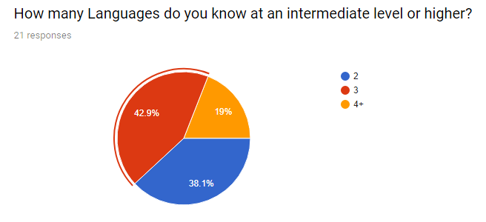

Figure 1 - How many languages each participant knows at a given level

Next question is to know where they learnt their languages, school or self-taught. As the participants have learnt more than 2 languages, some have learnt a language at school as well as teaching themselves a language.

Referring to Figures 2 and 3, following the question:” Has learning more than one language benefit you in anyway, if so, how?”

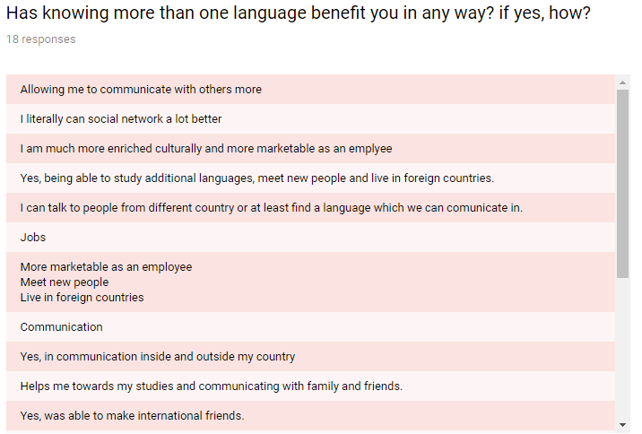

Figure 2 - Response to the question: how has learning more than one question benefitted you?

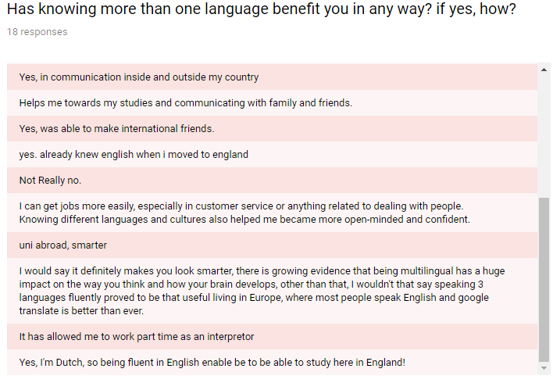

Figure 3 - rest of responses to the question: how has learning more than one question benefitted you?

Looking at the answers provided, they give insight into what people learn languages for, some because they have to, some because they want to improve themselves and accomplish something by self-teaching. To some, learning another language has opened up new opportunities when it comes to socialising and working in new environments that may require them to know another language. Learning a new language, even its basics can improve chances of getting a new job, people benefit indefinitely from it due to the fact employers will look for people who have understanding of other languages.

On the other hand, some results are critically viewing the perspective on how it has or has not benefit them. For example, some have learnt two or more languages, but are studying within the UK, this is not beneficial as most people speak English and have no need to speak their other known languages. In addition, languages are typically a requirement if someone wishes to study or work in another country, it can give a learner the incentive to improve himself or herself and study harder. Furthermore google translate has nowadays become a lot more efficient and accurate when it comes to translating words and sentences.

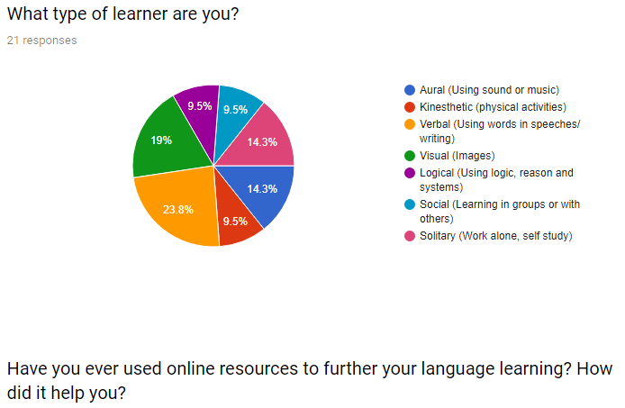

Figure 4 - Types of learners the participants are

As the project develops, its best to know what type of learners people are, that way the website can be designed accordingly to suit their needs. As seen in Figure 4 it should that just under half the participants are either visual or verbal learners, which is common as it is what is normally the main focus in schools and in the classrooms. Others prefer solitary study, or use music and/or sounds (podcasts).

Some have learnt languages solely from schools and have no used online resources to be able to improve their skills. Few used mobile apps such as Duolingo to allow constant studying daily no matter where they are, this generation is known for always using their mobile phones, so giving people the option of using language learning apps is very convenient. Other participants find it easier to watch movies, tv shows and by simply looking up words that they have heard in said movies and tv shows.

## 8.2 Motivation to learning –

At the start of the survey, the aim was to gather generic information that relates to learning languages, to then be able ask them what motivates them to learn languages other than the fact that they may have to (for school exams/tests etc.).

As some answers to what motivated them to learn was that they had to because of school or they were moving to a country that spoke another language and is required if they wish to work/study there. Others on the other hand found satisfaction in the outcomes of speaking another language to someone and seeing the surprise on their face.

What motivated others varied, some were just curious to learn, some did it for personal reasons such as travelling (English is one the most spoken languages in the world). While people learnt for travelling, it also opens their horizons to the countries culture, enforcing their motivation to improve and adapt. Growing up in different countries gives a completely perspective when they visit another country, learning a language before visiting a country can give a perspective into their future as it gives them more options that they can choose from (career paths).

The website is open for aspiring teachers and ambitious learners, from the perspective of the participants of the survey, they are all learners, but some have taken part in teaching other people. Not everyone has taught languages, but the ones that have find it difficult yet fulfilling, while it is also motivating for them. Some teach because it gives them satisfaction when students finally understand the lessons taught and are capable of using it casually. This shows that capabilities of this website, giving people the opportunity to teach a language to people who wish to learn from you. Although the skills aren’t necessarily going to meet professional expectations, they will have some form of knowledge on teaching their own language. Referring to figures 5 and 6, it shows that over half the participants have considered teaching their native language, while another chart shows how people felt after helping/teaching someone learn a language.

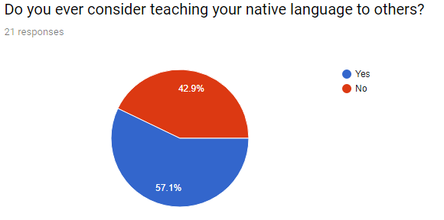

Figure 5 - Results of participants to see if they considered teaching

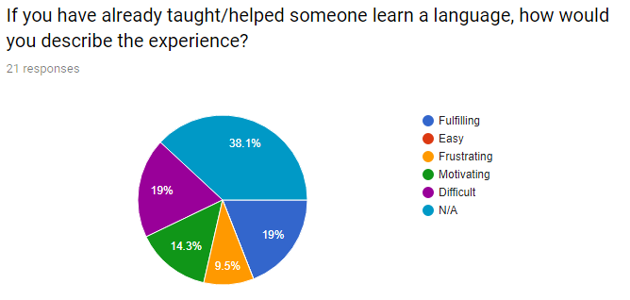

Figure 6 - Results to the question that describes their experiences when teaching a language.

From the generalised question: “From the perspective of a teacher, what would motivate you to stay on the website and teach?”

As some looked at the perspective of it being a job, they wanted good pay and flexible hours, whereas others looked for something other than money. The main aim of this question was to see if people wanted to teach languages freely but with exceptions to doing so. Of course providing a service, you would expect something in return such as payment for example, but the use of this website is to not necessarily provide professional help, and instead improve themselves by helping each other.

Results show that one-to-one communication is very beneficial to learning/teaching languages. Such information has put the project in the direction of allowing a one-to-one communication chat system to be created that will allow users to chat, share information, and provide support for each other. Below is figure 7 that shows the participants opinion on one-to-one communication.

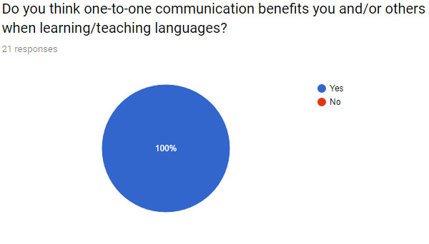

Figure 7 - Do you think one-to-one communication benefits you and/or others when learning/teaching languages?

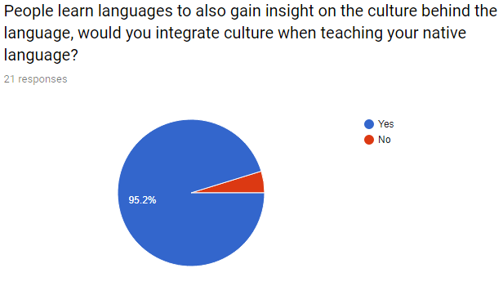

Figure 8 - Results to determine whether participants would integrate culture into teaching or not

From a teacher’s perspective, they may share information on the native languages culture, which can peak interest in some or most students. Most participants will implement their culture into teaching as it can also be easier to teach what you have learnt your whole life. Figure 8 shows that introducing culture to the classroom is encouraged due to the fact that it is a topic that can easily be integrated within lesson plans.

As people look towards online sources for language learning, it gives them the freedom of choice, if they were to stumble upon such a website that contains connections to aspiring language teachers, they can choose. Of course they would likely pick ones most skilled/qualified, but that option is not always available and doesn’t typically come free. Referring to Figures 9 and 10, participants give their preferences as to what they are looking for in an online language teacher.

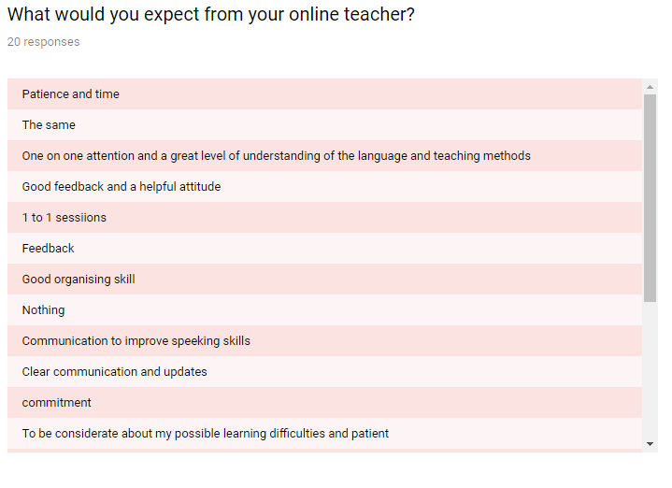

Figure 9 - What participants expect from online teachers

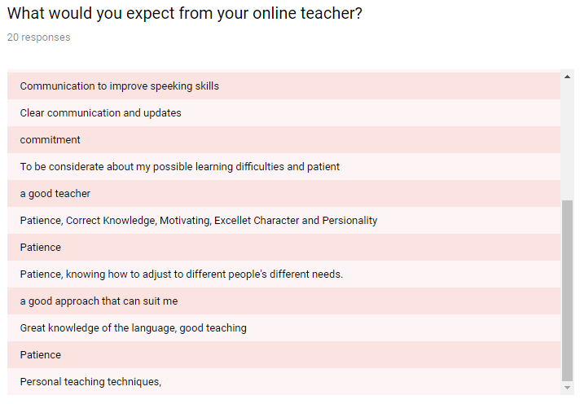

Figure 10 - Rest of answers from participants and what they expect from online teachers

As the website is being provided for free and just for the benefit of its users, there needs to be something that could be offered to its loyal users in the future as the website develops. There were many different results when it came asking participants: “What could be offered to teacher/students that will make them come back? “

Some were simply results where they just wanted the website to be free of use, others assumed that teachers would be given possibility for an income. As the question is taking from different perspectives, the learners would like some sort breakdown from the teachers when lessons are taught and simplified. The community as a whole would need to be positive, helpful and supportive of others.

On top of this, creating an environment that gives experience to teachers as they test new teaching methods while students are given free access to said learning materials, instead of using large commercial language learning websites.

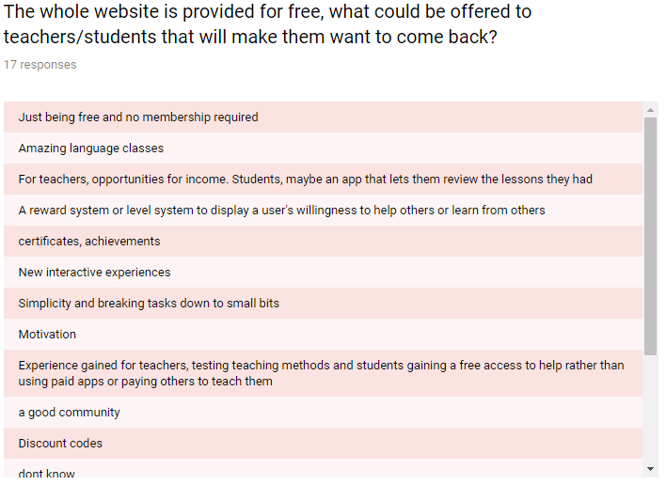

Figure 11 - Results to the question "The whole website is provided for free, what could be offered to teachers/students that will make them want to come back?"

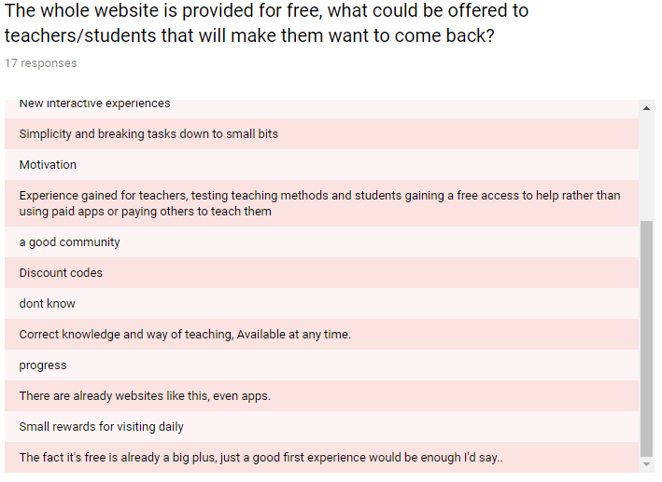

Figure 12 - Rest of results of the question "The whole website is provided for free, what could be offered to teachers/students that will make them want to come back?"

A question to summarise the survey is to see if the participants would actually use such a website that is being created for students and teachers to use in their own time for their own personal gains. Such research has given more insight into what the website should look like and how the user should be able to interact with it, they want it simplistic yet interactive to a certain extent where it doesn’t take up too much time or effort to find a student/teacher. What would motivate the users to come back to the website depends on not only the functionality of the website, but the effort put in by other users.

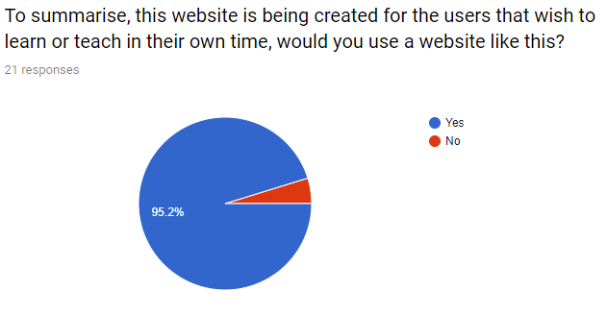

Figure 13 - Results of question "To summarise, this website is being created for the users that wish to learn or teach in their own time, would you use a website like this?"

# Chapter 9 Implementation –

Throughout the entire three-year course, many coding languages have been taught to a certain extent, allowing students to explore said languages and improve their skills for the later years to come. This section includes the languages, systems and operations used throughout the project. Some have been used for the final implementation, others have been disregarded, this is because they did not meet certain standards to create a functional website.

## 9.1 InfinityFree Hosting service –

InfinityFree is a website that offers hosting services for websites to allow them to create domains, databases that can then be accessed via the internet like any other website.

This service was being used at the beginning of the project, there were complications that led to the abandonment of the service. The main complication was the fact that it did not fully support Web-sockets, which is capable of enabling real time chat functions between users, this is one of the main implementation ideas for this project. *– InfintyFree(2019)* Such a problem has been averted as the university was able to provide a server that can be used to produce this prototype.

## 9.2 WebSocket –

To be able to create a web app that allows real-time updates, WebSocket provides two-way communication between clients and a remote host in real-time. To simplify WebSockets, it a protocol that allows servers to send push requests to clients, which in turn lets real-time communication possible. *- Tools.ietf.org. (2019).* Before this protocol, polling was something that was used instead for chat application communication, polling is where the users ask the server for updates at set times, whereas WebSocket uses server pushing, meaning the server is constantly sending back updates to its users. - Ganesan, B. (2019).

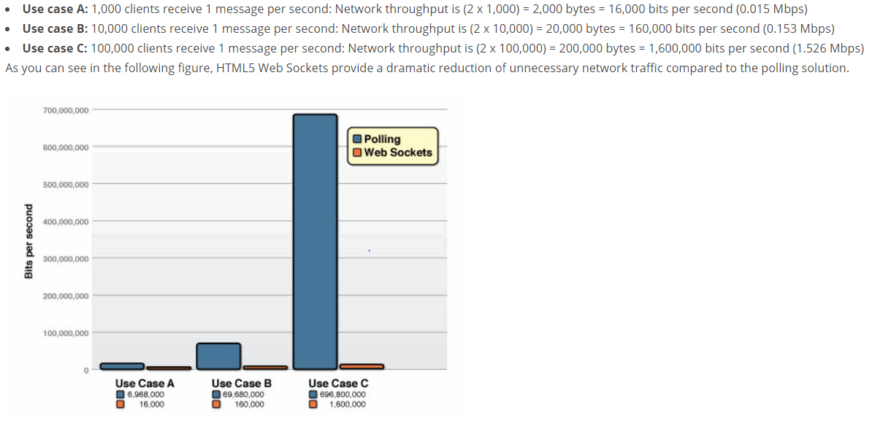

Figure 14 - Bits per second comparison between WebSockets and Polling sending small messages (Lubbers and Greco, n.d. 2019)

Referring to the figure above, the comparison between WebSockets and Polling has a massive difference in Bits usage when 100,000 people send small messages every second. From Case A is shows a slight difference, same as Case B; this suggest that depending on how many people will be messaging the server, it may or may not create unnecessary traffic.

As it stands, WebSocket is not the only way to be able to create a real-time web app, and due to some minor issues that set the project back, WebSocket has not be chosen for the final stages of the project. The error itself came from a command line used to setup the server: PuTTy, the server itself gave no errors but was not running properly as the chat could not connect with another user. WebSocket was just one option that could be used to implement the prototype, currently WebSocket is not being used anymore as another method has been found.

## 9.3 HTML/PHP/AJAX Short Polling –

Polling in technical terms it is a modal that constantly check other codes to see what states they are in. Short polling is what is in the prototype, which will allow close ‘real-time’ communication between client and server. This method used for the prototype website uses AJAX and polling, which lets the client ‘poll’ the server for something, for example a message from another person. AJAX will request information from the server, which will always be open until it has new data to send to the browser. This is the method approach taken for the final implementation of the prototype. Referring to Figure 14, depending on how many users are going to be using the website from the start, either WebSockets or Short Polling would be viable at the initial implementation, because of this, Polling will the method used to create the main function for the prototype.

## 9.4 Showing implementation -

This searchpeople.php form allows users to look for teachers or students of a specific language.

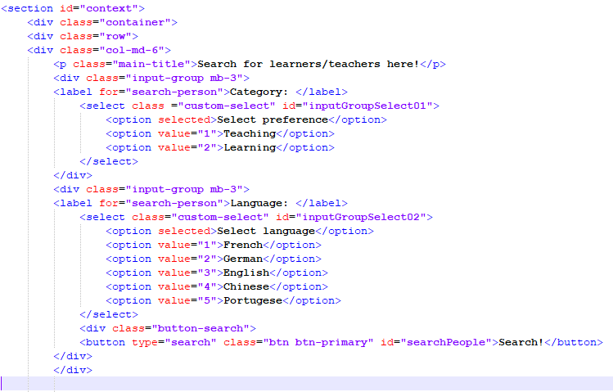

Figure - First page when searching fora teacher/learner

This creates the button that is sent to a JavaScript page to search for users.

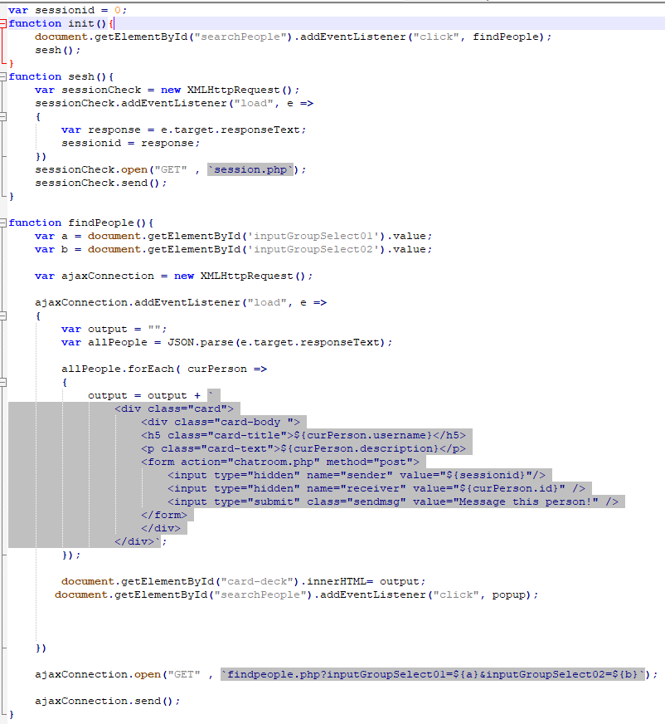

Global variable of sessionid set to 0, will allow it to be accessed by another function. Function init() pulls the form from searchpeople.php with getElementByID(“searchPeople”).

Function init() creates a link to Function findPeople as shows.

Function findpeople reads the options the user has chosen. An Ajax connection with a HttpRequest will be created.

Function init() creates a link to Function findPeople as shows.

Function findpeople reads the options the user has chosen. An Ajax connection with a HttpRequest will be created.

Figure 16 - findpeople javasript page that searchs for users and sends information back to the searchpeople.php page

The Ajax connection creates an eventlistener along with a JSON parse, allowing it to create a loop to display HTML when it connects to the PHP page to find users.

The Ajax connection opens with a method of GET with the users selection info, and is sent to findpeople.php.

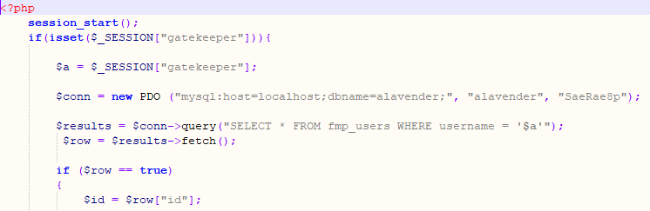

This query uses SELECT statement that is looking at a specific table where the username is the gatekeepers id, that would be the person that has logged in.

New PDO creates a connection to the server.

$_SESSION gatekeeper is the logged in user.

Figure - php that searches the users username and checks they are online.

Reads inputs from the searchpeople.php form using a method of GET with created variables to reference later.

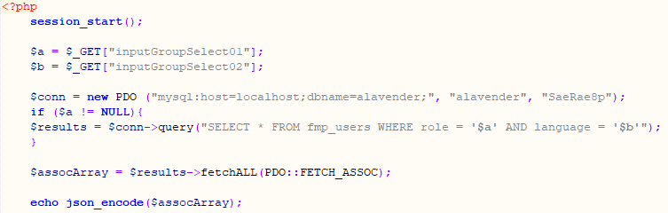

$assocArray and fetchALL is used to grab all possible results based on the users search form.

Figure 18 - php page that gets all users from selected options

Json_encode is used to be sent back the findpeople.js page which then displays the results found into the searchpeople.php page.

This form then creates the link to the chatroom.php, while reading in hidden fields with given id’s to be read by the chat.js script. When the button is clicked, it has now read the id of the receiver and the sender.

When it finds the users it will display users with this layout, while its filled with the users specific inputs.

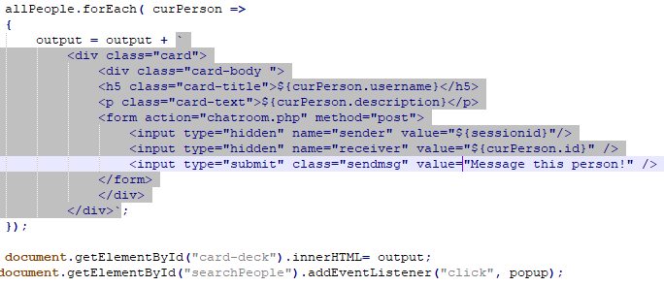

Figure - HTML layout of found users

Chatroom.php is essentially a page that is awaiting results from other pages as messages are sent and received, it has a small form that includes text and a submit button. See the figure below. Although it does have a hidden variable that gets the id of the person the user wishes to message.

With the id of main, it allows the link to the chat.js page.

## 

Figure 20 - Form used to send messages.

Input id of “message-text” is read by the JavaScript once it has been submitted by “btn1”

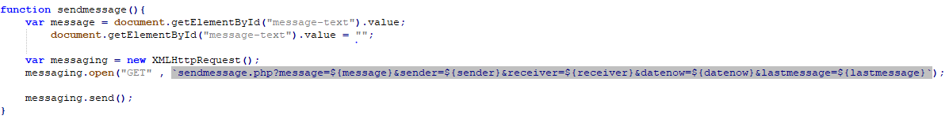

The button sends the input to chat.js which contains a function sendmessage. It grabs the input with document.getElementById and creates a HttpRequest to a PHP page with a GET request.

Figure - Script that runs when the user clicks send

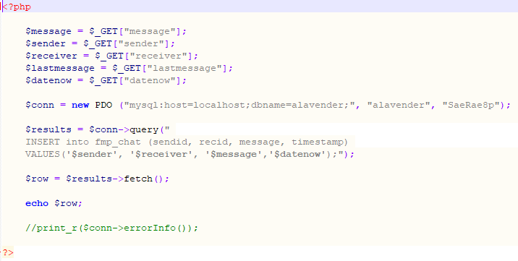

Created variables that reads the message, users id, receivers id, last message and the date.

Figure - PHP page that reads the message sent and posts to database with given variables

Said variables are sent to the database via INSERT SQL statement.

This loop has setInterval which sets a refresh timer every second (1000ms). This loop will go through to another PHP script to look for any new received messages or any new sent messages, before outputting them into the chatbox(chat-display).

As it runs the SQL query within figure 22, a loop within Chat.js will be running and searching for anything new within the database.

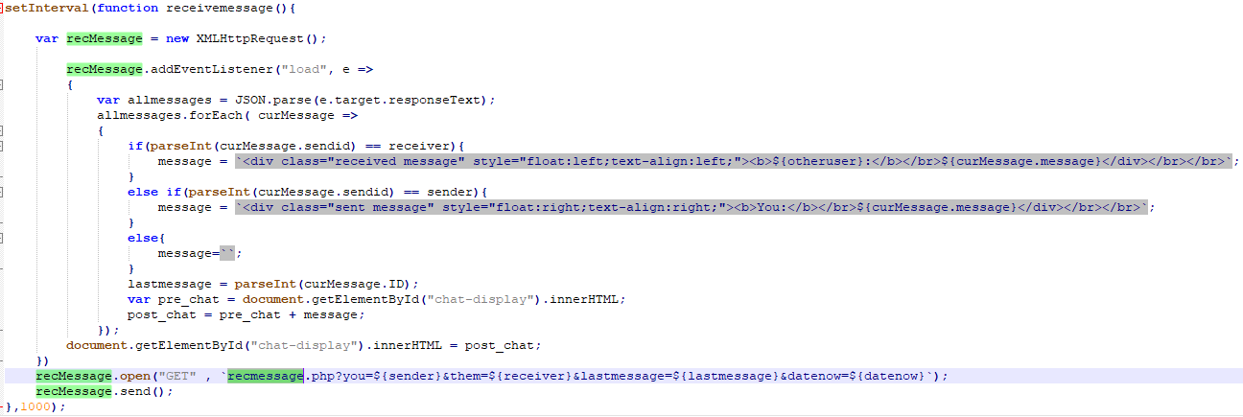

Figure - JavaScript loop looking for new data from recmessage.php

While it is looking for specific ID’s, the query needs an exception to call the ID of the last message and make sure the ID is larger than the ID before.

Similar to sendmessage.php, but using a SELECT query to call all messages associated with the senders ID and the receivers ID.

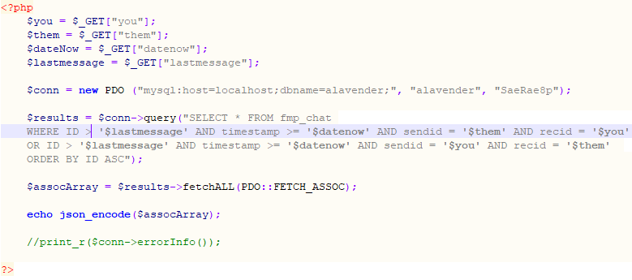

Figure - PHP SELECT query to pull the last message sent in the chat

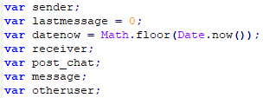

Figure - Global variables used in Chat.js

Within Chat.js are multiple global variables that are being called in multiple functions. They are all different as some are used for sending a message, receiving a message, posting to chat, setting the date within a timestamp and setting the last message sent/received.

## 9.5 Addressed Issues -

While it was being developed, it was not presenting errors into the system at first, until the JavaScript page to develop the chat room had an unexpected error where the messages were not send back to the sender or the receive; it instead sent back the word “undefined” in the area the message was supposed to be.



Figure 26 - fixed issue of chatroom not sending back any messages.

From the figure above you can see the “GET” request, before it was amended, it was originally a “POST” request, for a HTTP request, it would need to be a “GET” that way the query can be built properly.

As soon as the error had resolved itself, To test to see if it was sending anything at all to the webpage, by simply replacing {receiver} and {sender} with the users ID that should be in the chatroom together. The code was ‘working’ but it was sending back numbers from the server instead of the message, this was then discovered to be a problem within the IF statement inside the AJAX query.

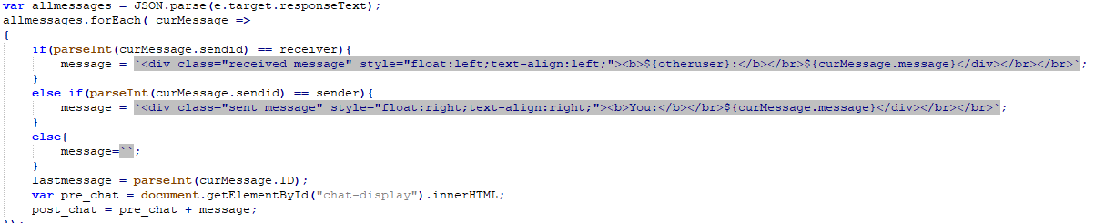

Figure 27 - line of code to produce message received into the chat room

The issue that had been discovered was that the system was sending in the messages as STRINGS, it read them from the database which were labelled by ID’s, so it was sending back numbers instead of the message. As the figure from above is using quotation marks, it was sending the numbers back as STRINGS.

The hint was the number, and the fact it sent back numbers was a second clue. This is where the parseInt() code comes into play, as seen in the figure above, it had to parse the integer from the STRING. For example it was sending “1” as the number instead of 1, so it was not reading it properly, and therefore not sending the message back to the chat room.

# Chapter 10 Conclusions –

Throughout the dissertation there have been many different choices made, such decisions include changing server hosting services to ones more fit for the project idea, changing the method of approaching said prototype and how to get it functional. What has been shown within the dissertation is what steps have been taken to produce something functional and interactive for its given audience, to a certain extent, it has broadened perspectives in terms of web development. Multiple approaches were taken to see if there were different methods to implement the main functions of the prototype, it has been proven that there can be multiple approaches that allow similar, efficient functionality.

Each chapter represents the steps that gives reasoning behind the dissertation

As research findings and results are collected into one whole report, it confirms that ideas can be made into fruition, although the prototype is not near being published publically, it has depth and understanding due to research conducted. While aims were met, it gave room to grow, like all websites, there is always something new, more efficient and more enticing that can be added to improve itself.

As research advanced, it gave crucial information that can support the progress of the prototype. The literature review has provided the dissertation with enough research, feedback, and general knowledge that it shows that there will always be more information released based on language learning theories and language teaching theories. To expand on this, within the given time there is only so much research that can be assembled and analysed properly.

In regards to the hypothesis that has started the prototype from the beginning, to see whether such an idea can thrive and compete with the large amount of commercial websites that facilitate language learning. The answer itself is more clear, and to say the least it is possible that such a website can compete and thrive within such a competitive community which already has a large fan base. With time, effort and dedication, the prototype can be turned into something that could possibly flourish in the current market for language learning/teaching websites.

## 10.1 Ethics form alterations –

Firstly, creating the ethics form has its issues because filling out initially had some mistakes, these mistakes implied that personal information would be stored regarding sensitive/offensive topics. This was not the case and assumptions made were wrong, at this current stage they have been corrected and it is not been approved by the supervisor. It has been realised that it is not necessary to have participants take part in testing the website as the survey taken had anonymous users, while also giving sufficient feedback on the development of the website.

# Chapter 11 Recommendations for further work and/or discussion –

As far as the prototype stands, it will always have work needed on it, as the internet computing languages is always evolving, websites must evolve with it or it will become irrelevant to modern web technology. Further research would be required to be able to progress the website when it comes to understanding the issues students and teachers face, as they look for good websites that they can use freely.

To make the functional more fluent and efficient, code needs to be adjusted to be able to pull all messages between two people as at the current moment it displays the last message sent/received. The possible approach to tackle this idea and allow it to display the whole chat history between two people, is to take the final select statement that produces the initial message and make it produce all messages where the ID’s match the users in the chatroom. After careful consideration, it may have to go into another PHP script because if the JavaScript loop has been amended in the wrong way it could break the loop and potentially constantly send back the same message.

For the future developments, it would be recommended to integrate from using shot pulling to using Web Sockets due to the fact it will be able to hold a larger amount of traffic while handling less bits a second. As well as this, it is capable of holding real-time chat communications with users, unlike short polling which is not real-time. If there were more time given, followed by the understanding of what needs to be done, implementation of such new methods can be completed.

# References -

Boden, C. (2019). *Ratchet - PHP WebSockets*. [online] Socketo.me. Available at: <http://socketo.me/> [Accessed 10 Mar. 2019].

Bolin, B. and A. Tysver, D. (2018). *Web Site Legal Issues (BitLaw)*. [online] Bitlaw.com. Available at: https://www.bitlaw.com/internet/webpage.html [Accessed 2 Feb. 2019].

*Decci, E and Ryan, R (2000). What and why of goal pursuit: Human needs and the self-determination of behaviour. Psychological Inquiry 11, 319-338[online] Available at:* <https://www.researchgate.net/publication/321126153_Language_Teacher_Motivation> [Accessed 21 Feb.2019]

Duolingo. (2019). *Learn a language for free*. [online] Available at: <https://www.duolingo.com> [Accessed 24 Feb. 2019].

Falbe, T. (2018). *Ethical Design: The Practical Getting-Started Guide*. [online] Smashing Magazine. Available at: https://www.smashingmagazine.com/2018/03/ethical-design-practical-getting-started-guide/ [Accessed 2 Feb. 2019].

Falbe, T. (2018). *Ethical Design: The Practical Getting-Started Guide*. [online] Smashing Magazine. Available at: https://www.smashingmagazine.com/2018/03/ethical-design-practical-getting-started-guide/ [Accessed 2 Feb. 2019].

Hale, C., & French, D. (1999). Web-related Assessment and Evaluation. In: French, D., Internet Based Learning: An Introduction and A Framework for Higher Education and Industry, USA: Stylus Publications. *[online] Oro.open.ac.uk. Available at: http://oro.open.ac.uk/58794/7/58794.pdf [Accessed 14 Feb. 2019].*

HelloTalk. (2019). *HelloTalk | Free Language Exchange | Language Partners*. [online] Available at: https://www.hellotalk.com/?lang=en [Accessed 13 Feb. 2019].

*Hiver. P and Tae-Young Kim (2018). Language Teacher Motivation. [online] Available at:* <https://www.researchgate.net/publication/321126153_Language_Teacher_Motivation> [Accessed 21 Feb.2019]

InfinityFree. (2019). *Free and Unlimited Web Hosting with PHP and MySQL*. [online] Available at: <https://infinityfree.net/> [Accessed 5 Mar. 2019].

Jones, J. (2019). *Open Culture - The Best Free Cultural and Educational Media on the Web.* [online] Open Culture. Available at: <http://www.openculture.com/> [Accessed 24 Feb. 2019].

*Klassen, R., Tze, V.M., Betts, S. and Gordon, K.(2011)Teacher efficacy research 1998-2009: Signs of progress or unfulfilled promise. Educational Psychology Review 23, 21-43. [online] Available at:* [*https://www.researchgate.net/publication/321126153_Language_Teacher_Motivation*](https://www.researchgate.net/publication/321126153_Language_Teacher_Motivation) *[Accessed 23 Feb.2019]*

*Kukulska-Hulme, A. and Shield, L. (2004). [online] Oro.open.ac.uk. Available at: http://oro.open.ac.uk/58794/7/58794.pdf [Accessed 14 Feb. 2019].*

Laurillard, D. (2002). Rethinking University Teaching: A Conversational Framework for the Effective Use of Learning Technologies (2nd ed.). London and New York: Routledge. *[online] Oro.open.ac.uk. Available at: http://oro.open.ac.uk/58794/7/58794.pdf [Accessed 14 Feb. 2019].*

# Lavender, A. (2019). Access to websites final code *AstonLavender96/FMP*. [online] GitHub. Available at: https://github.com/AstonLavender96/FMP [Accessed 2 May 2019].

Liuolienė, A. and Metiūnienė, R. (2006). *Second Language Learning Motivation*. [online] Citeseerx.ist.psu.edu. Available at: <http://citeseerx.ist.psu.edu/viewdoc/download?doi=10.1.1.828.2586&rep=rep1&type=pdf> [Accessed 21 Feb. 2019].

Lubbers, P. and Greco, F. (n.d.). WebSocket and Polling comparison image. *HTML5 WebSocket - A Quantum Leap in Scalability for the Web*. [online] Websocket.org. Available at: http://websocket.org/quantum.html [Accessed 2 Apr. 2019].

Mae Sincero, S. (n.d.). *Cognitive Learning Theory - Using Thinking to Learn*. [online] Explorable.com. Available at: https://explorable.com/cognitive-learning-theory [Accessed 25 Feb. 2019].

*Retelsdorf,J., Butler, R., Streblow, L. and Schiefele, U.(2010) – Teachers’ goal orientations for teaching: Associations with instructional practices and teachers’ engagement. Learning and Instruction 20, 30-46[online] Available at:* <https://www.researchgate.net/publication/321126153_Language_Teacher_Motivation> [Accessed 21 Feb.2019]

*Richardson, P.W., Karabenick, Sa.A, and Watt, H.M (2014) teacher motivation matters: an introduction. In P.W. Richardson, S.A. Karabenick and H.M. Watt(eds) Teacher Motivation: Theory and Practice (pp. xiii-xxii). New York: Rouledge. [online] Available at:* [*https://www.researchgate.net/publication/321126153_Language_Teacher_Motivation*](https://www.researchgate.net/publication/321126153_Language_Teacher_Motivation) *[Accessed 23 Feb.2019]*

*Tools.ietf.org. (2019).* *RFC 6455 - The WebSocket Protocol*. [online] Available at: https://tools.ietf.org/html/rfc6455#section-1.1 [Accessed 20 Mar. 2019].

WAI (2014). *Legal and ethical issues in Web Design*. [online] 4mdesigners.com. Available at: https://www.4mdesigners.com/articles/legal-and-ethical-issues-in-web-design/ [Accessed 2 Feb. 2019].

*Wigfield, A and Eccles, J. S (2000) Expectancy-value theory of achievement motivation. Contemporary Educational Psychology 25, 68-81. [online] Available at:* <https://www.researchgate.net/publication/321126153_Language_Teacher_Motivation> [Accessed 23 Feb.2019]

*Zee, M. and Koomen, H.(2016) Teacher self-efficacy and its effects on classroom processes, student academic adjustment, and teacher well-being: A synthesis of 40 years of research. – Review of Educational Research. doi:10.3102/0034654315626801 [online] Available at:* [*https://www.researchgate.net/publication/321126153_Language_Teacher_Motivation*](https://www.researchgate.net/publication/321126153_Language_Teacher_Motivation) *[Accessed 23 Feb.2019]*

# Bibliography –

Brownsbfs.co.uk. (2019). *vle foreign languages*. [online] Available at: https://brownsbfs.co.uk/Pages/vlebooks/vle-foreign-languages [Accessed 13 Feb. 2019].

Connelly, M. (2014). *7 Outstanding Language-Learning Apps and Websites*. [online] Fodors Travel Guide. Available at: https://www.fodors.com/news/7-outstanding-language-learning-apps-and-websites-11121 [Accessed 12 Feb. 2019].

Italki.com. (2019). *italki: Learn a language online*. [online] Available at: https://www.italki.com/home [Accessed 12 Feb. 2019].

Phppot. (2019). *Simple PHP Chat using WebSocket - Phppot*. [online] Available at: https://phppot.com/php/simple-php-chat-using-websocket/ [Accessed 19 Apr. 2019].

Sanwebe.com. (2013). *Simple Chat Using WebSocket and PHP Socket – Sanwebe*. [online] Available at: https://www.sanwebe.com/2013/05/chat-using-websocket-php-socket [Accessed 15 Apr. 2019].

Stack Overflow. (2013). *Long polling chat system*. [online] Available at: https://stackoverflow.com/questions/15850962/long-polling-chat-system [Accessed 19 Apr. 2019].

Stack Overflow. (2013). *Sending message to a specific connected users using webSocket*. [online] Available at: https://stackoverflow.com/questions/16280747/sending-message-to-a-specific-connected-users-using-websocket/16320011 [Accessed 11 Mar. 2019].

Stack Overflow. (2019). *Change navbar in bootstrap if user login*. [online] Available at: https://stackoverflow.com/questions/27209274/change-navbar-in-bootstrap-if-user-login [Accessed 24 Mar. 2019].

YouTube. (2013). *Create Chat room in PHP (Long Polling) - Part 1*. [online] Available at: https://www.youtube.com/watch?v=2imEGa8FI00 [Accessed 23 Apr. 2019].

# Appendices –

## Appendix 1 – Ethics Release form



